 | 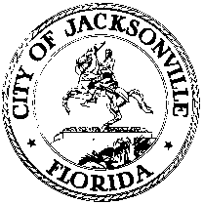
 | OFFICE OF THE CITY COUNCIL
ANNA LOPEZ BROSCHE  PRESIDENT  JACKSONVILLE CITY COUNCIL  OFFICE (904) 630-1452 |  | SUITE 425, CITY HALL  117 WEST DUVAL STREET  JACKSONVILLE, FLORIDA  32202
TASK FORCE ON OPEN GOVERNMENT
AGENDA
May 17, 2018
Don Davis Room
1:00 pm

Introductions

Public Records Requests-follow up
Craig Feiser- Office of General Counsel
Martha Foote- Public Records Request Coordinator (invited but not confirmed)

Community Access to Government
Available CPAC chairs and members

Closing Comments
Discussion and Planning
Public Comment

Chairs: Hank Coxe and Dr. Sherry Magill
Members: Ywana Allen
Rachael Fortune
The Honorable Alberta Hipps
Ron Littlepage
Michael Lockamy
Audrey Moran
The Honorable Jim Overton
Sabeen Perwaiz
Cleve Warren

The next Task Force Meeting will be Thursday, May 24, 2018 at 1:00 pm
in the Lynwood Roberts 117 West Duval Street, 1st Floor

